Name: Rushikesh Deore

NUID: 002766913

**Task**: In this assignment, your task is to determine--for sorting algorithms--what is the best predictor of total execution time: comparisons, swaps/copies, hits (array accesses), or something else.

**Program output:**

Screenshot for the table created for better understanding:

**Merge Sort: Instrument true**

|  |  |  |  |  |  |
| --- | --- | --- | --- | --- | --- |
| N | MS | Hits | Copies | Swaps | Compares |
| 10,000 | 4.29 | 489,780 | 220,000 | 0 | 121,505 |
| 20,000 | 9.22 | 1,059,563 | 480,000 | 0 | **263,004** |
| 40,000 | 19.54 | 2,279,129 | 1,040,000 | 0 | 566,011 |
| 80,000 | 46.8 | 4,878,171 | 2,240,000 | 0 | 1,212,010 |
| 160000 | 95.26 | 10,396,583 | 4,800,000 | 0 | 2,584,126 |
| 256000 | 177.42 | 17,366,935 | 8,105,984 | 0 | 4,303,134 |

|  |  |  |  |
| --- | --- | --- | --- |
| lg(N) | log-hits | log-copies | log-compares |
| 4 | 5.690001047 | 5.342422681 | 5.08459415 |
| 4.301029996 | 6.025126784 | 5.681241237 | 5.419962354 |
| 4.602059991 | 6.357768907 | 6.017033339 | 5.752824871 |
| 4.903089987 | 6.68825702 | 6.350248018 | 6.083506203 |
| 5.204119983 | 7.016890625 | 6.681241237 | 6.412313686 |
| 5.408239965 | 7.239723179 | 6.908805742 | 6.63378487 |

**HeapSort**

|  |  |  |  |  |  |
| --- | --- | --- | --- | --- | --- |
| N | MS | Hits | Copies | Swaps | Compares |
| 10,000 | 2.81 | 967,547 |  | 124,203 | 235,368 |
| 20,000 | 6.37 | 2,095,143 |  | 268,409 | 510753 |
| 40,000 | 13.91 | 4,510,161 |  | 576,797 | 1,101,487 |
| 80,000 | 33.36 | 9,660,359 |  | 1,233,604 | 2,362,971 |
| 160000 | 71.82 | 20,600,125 |  | 2,627,088 | 5,045,887 |
| 256000 | 141.83 | 34,308,296 |  | 4,371,906 | 8,410,336 |
| **QuickSortDualPivotvsMergeVsHeap**   |  |  |  |  | | --- | --- | --- | --- | | N | MergeSort | QuickSortDual | HeapSort | | 10,000 | 4.29 | 2 | 2.81 | | 20,000 | 9.22 | 5 | 6.37 | | 40,000 | 19.54 | 10 | 13.91 | | 80,000 | 46.8 | 24 | 33.36 | | 160000 | 95.26 | 53 | 71.82 | | 256000 | 177.42 | 88 | 141.83 | |  |  |  |  |  |

Hits done by all sorts

|  |  |  |  |
| --- | --- | --- | --- |
| N | MergeSort | QuickSortDual | HeapSort |
| 10,000 | 489,780 | 139,521 | 967,547 |
| 20,000 | 1,059,563 | 295,748 | 2,095,143 |
| 40,000 | 2,279,129 | 623,877 | 4,510,161 |
| 80,000 | 4,878,171 | 1,329,259 | 9,660,359 |
| 160000 | 10,396,583 | 2,784,343 | 20,600,125 |
| 256000 | 17,366,935 | 4,664,420 | 34,308,296 |

Number of Compares for all sorts

|  |  |  |  |
| --- | --- | --- | --- |
| N | MergeSort | QuickSortDual | HeapSort |
| 10,000 | 121,505 | 160,064 | 235,368 |
| 20,000 | **263,004** | 295,748 | 510753 |
| 40,000 | 566,011 | 623,877 | 1,101,487 |
| 80,000 | 1,212,010 | 1,329,259 | 2,362,971 |
| 160000 | 2,584,126 | 2,784,343 | 5,045,887 |
| 256000 | 4,303,134 | 4,664,420 | 8,410,336 |

|  |  |  |  |
| --- | --- | --- | --- |
| lg(N) | log-MergeSort | log-QuickSortDual | log-Heap |
| 4 | 5.08459415 | 5.204293666 | 5.371747417 |
| 4.301029996 | 5.419962354 | 5.470921816 | 5.708210926 |
| 4.602059991 | 5.752824871 | 5.795098975 | 6.041979376 |
| 4.903089987 | 6.083506203 | 6.123609609 | 6.373458392 |
| 5.204119983 | 6.412313686 | 6.444722734 | 6.70293752 |
| 5.408239965 | 6.63378487 | 6.668797649 | 6.924813347 |

**Github Repo URL:** <https://github.com/rishdeore44/INFO6205.git>

**Conclusion**: On a log-log graph, the relationship between the number of Hits, Copies, and Compares and the number of elements appears to be linear. In the case of Merge Sort, which has a time complexity of O(n log n), the number of Compares plays the most significant role in determining the total execution time of the algorithm. Although the number of Hits, Copies, and Swaps also increase with the number of elements, their impact on the overall time complexity is relatively minor when compared to the number of Compares.

**Eclipse output from console:**

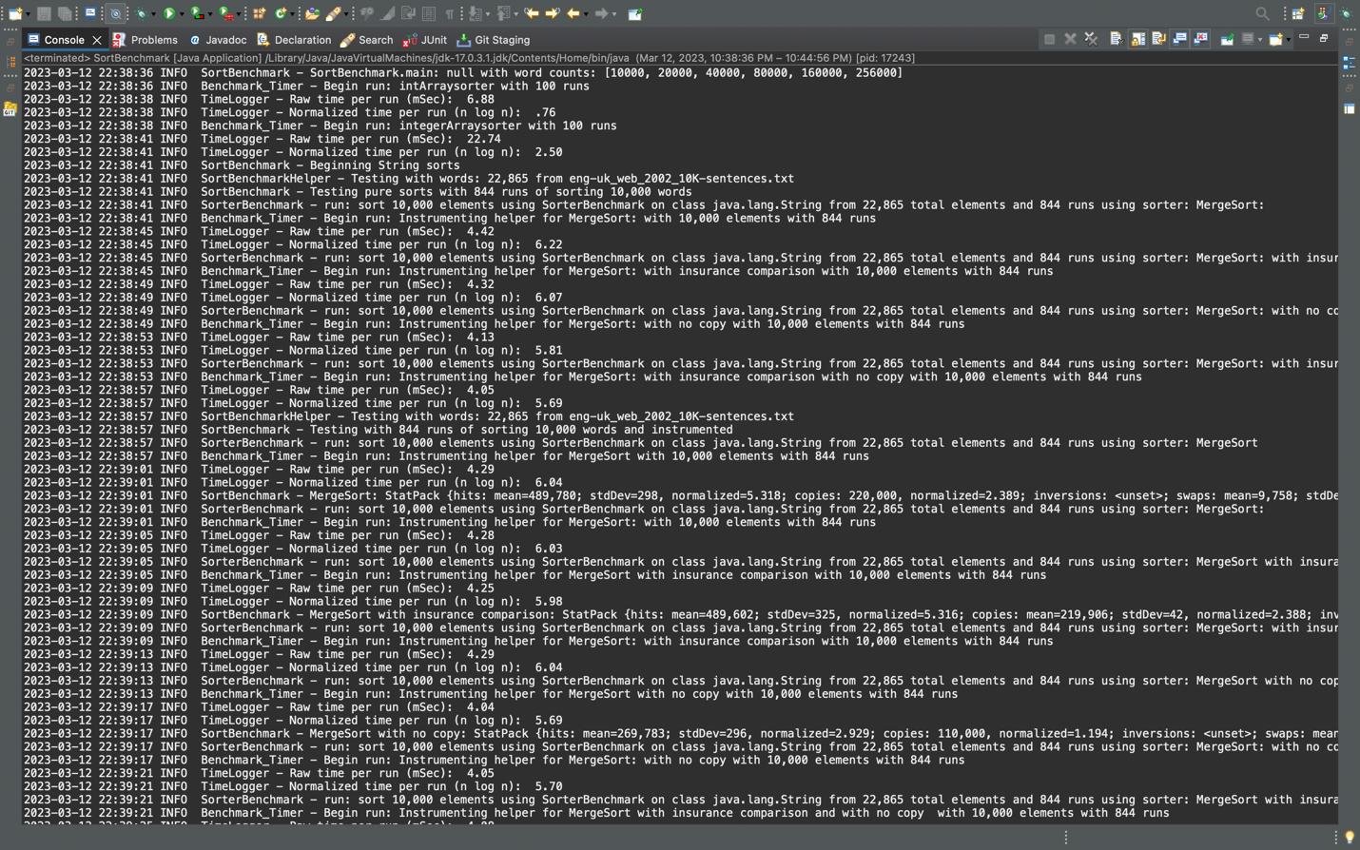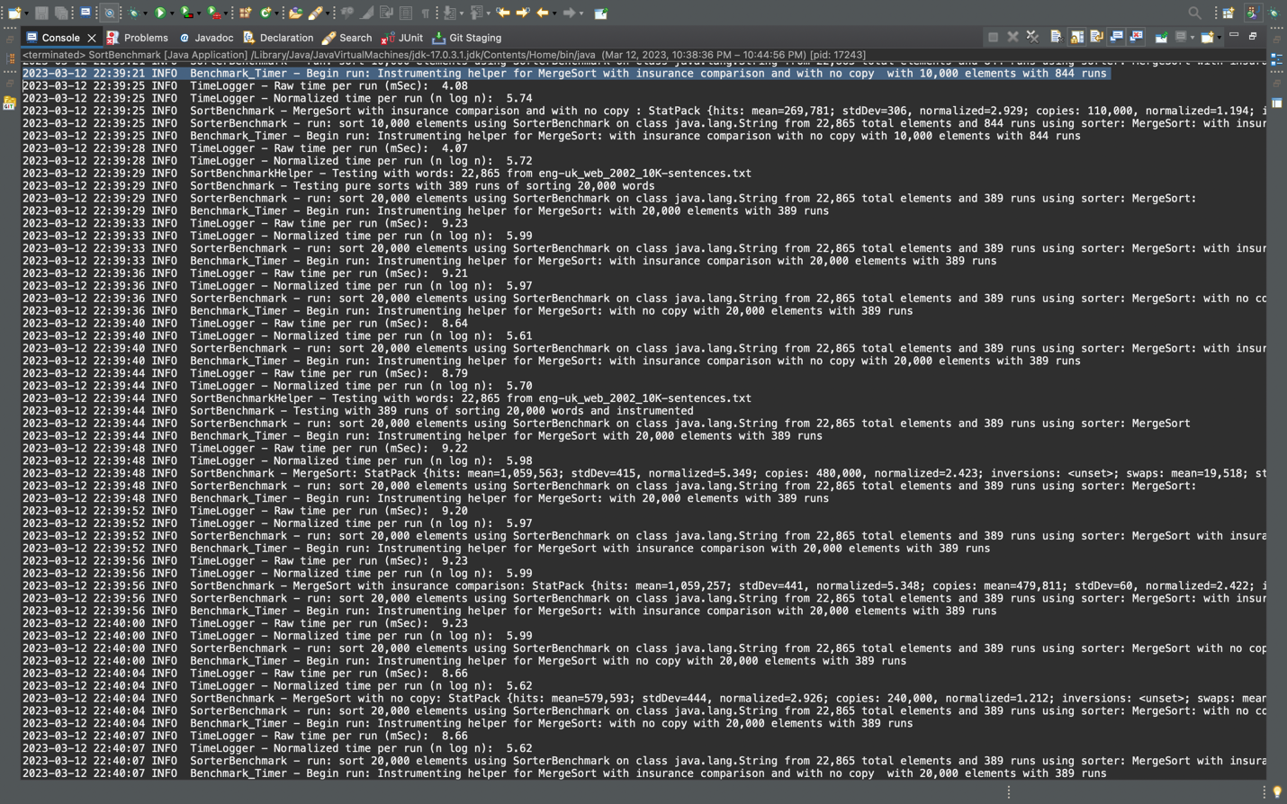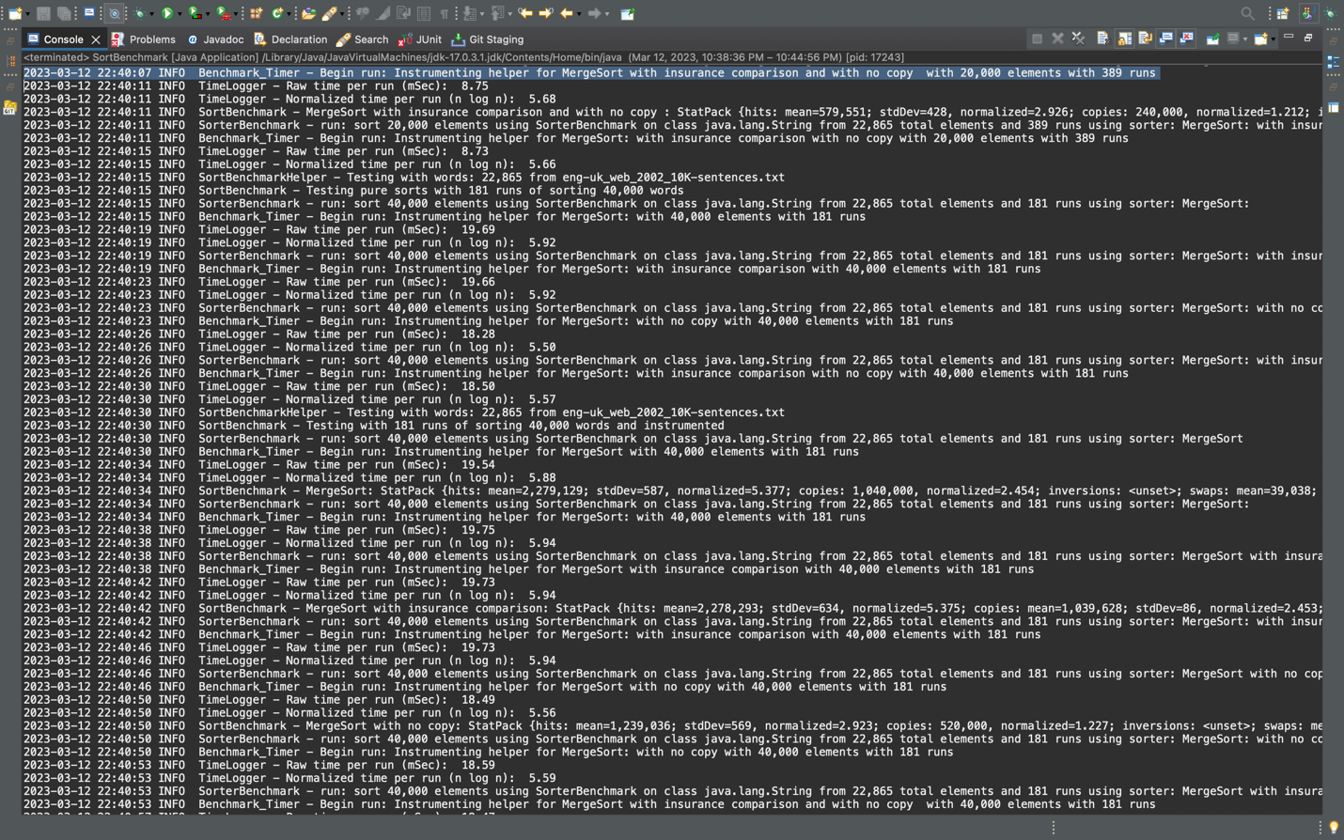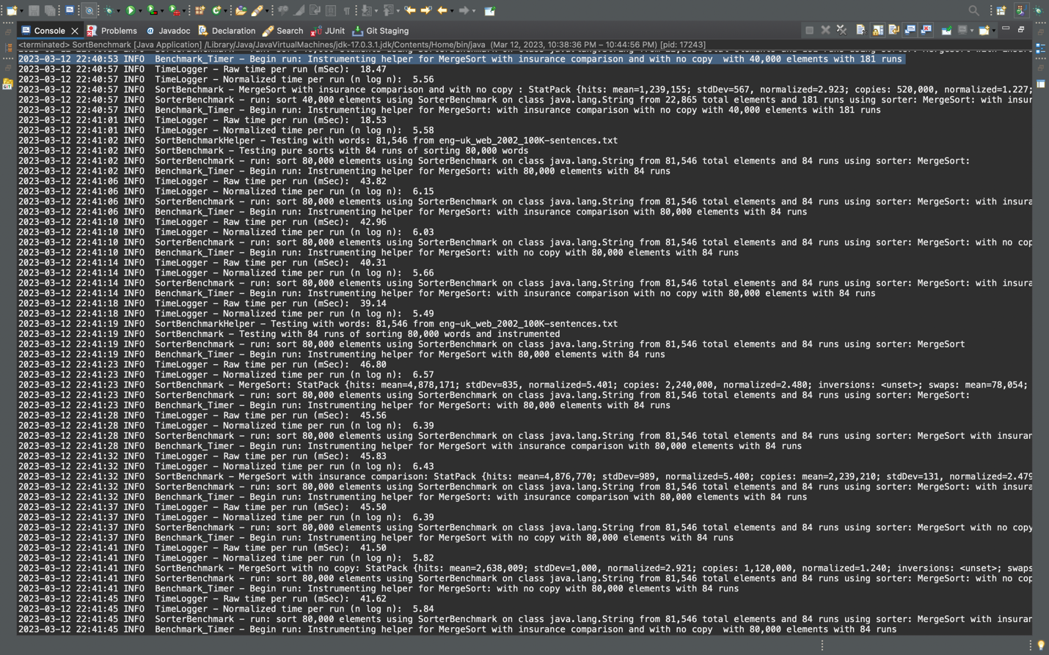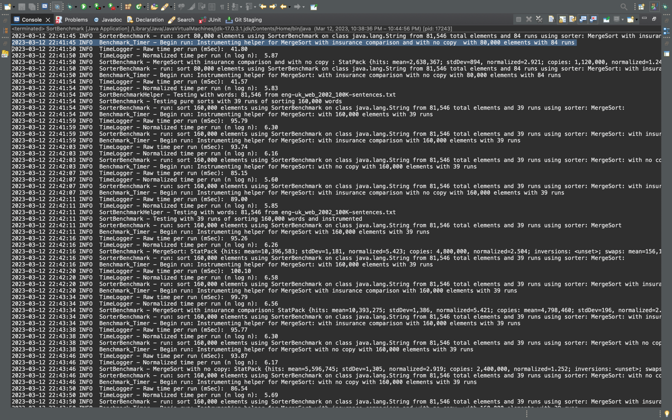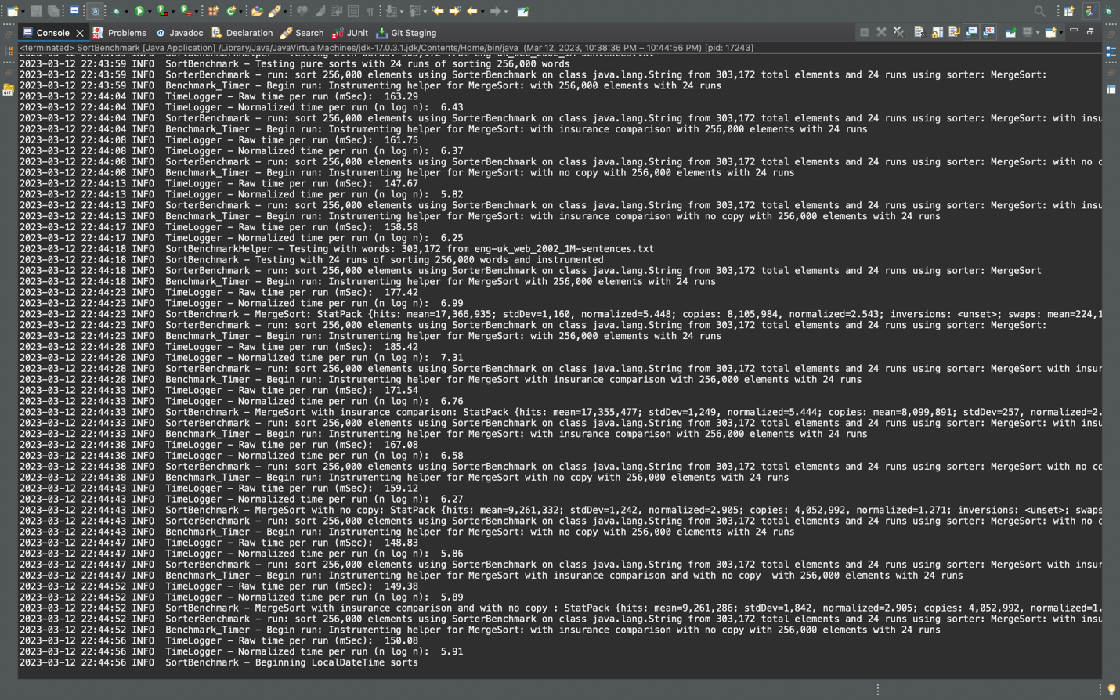

**Heap sort Instrumented:**

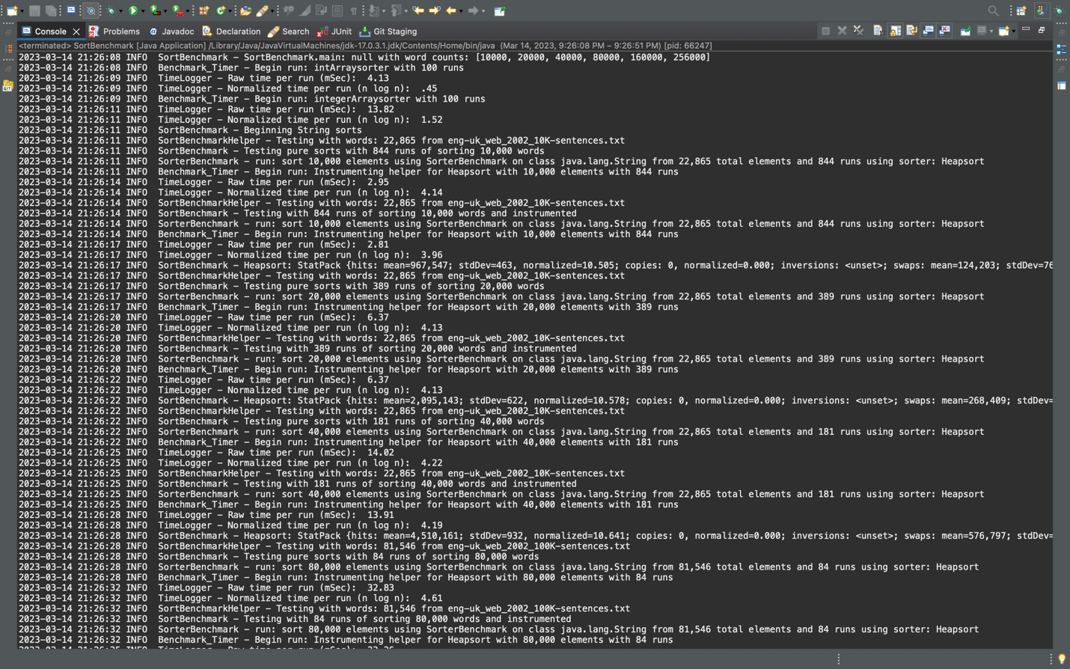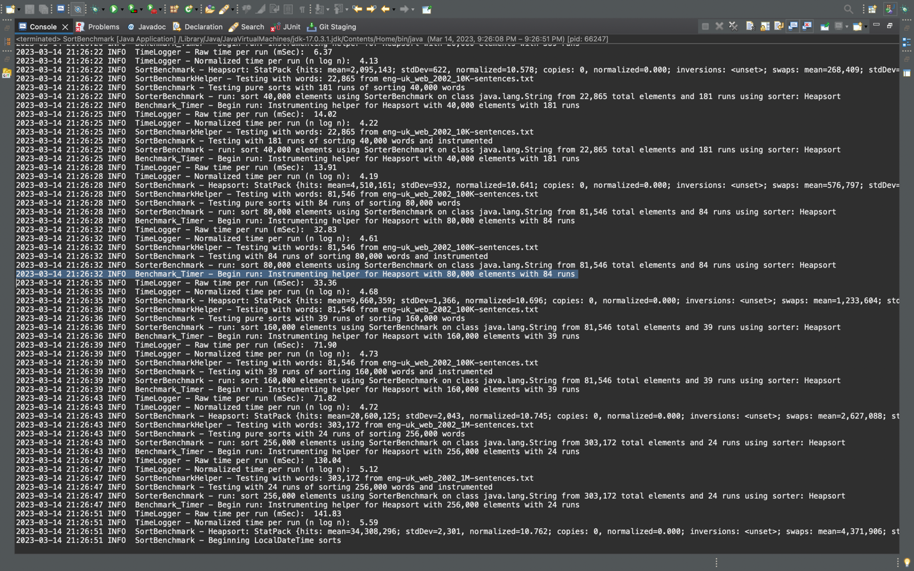

**Qick sort dual pivot instrumented:**

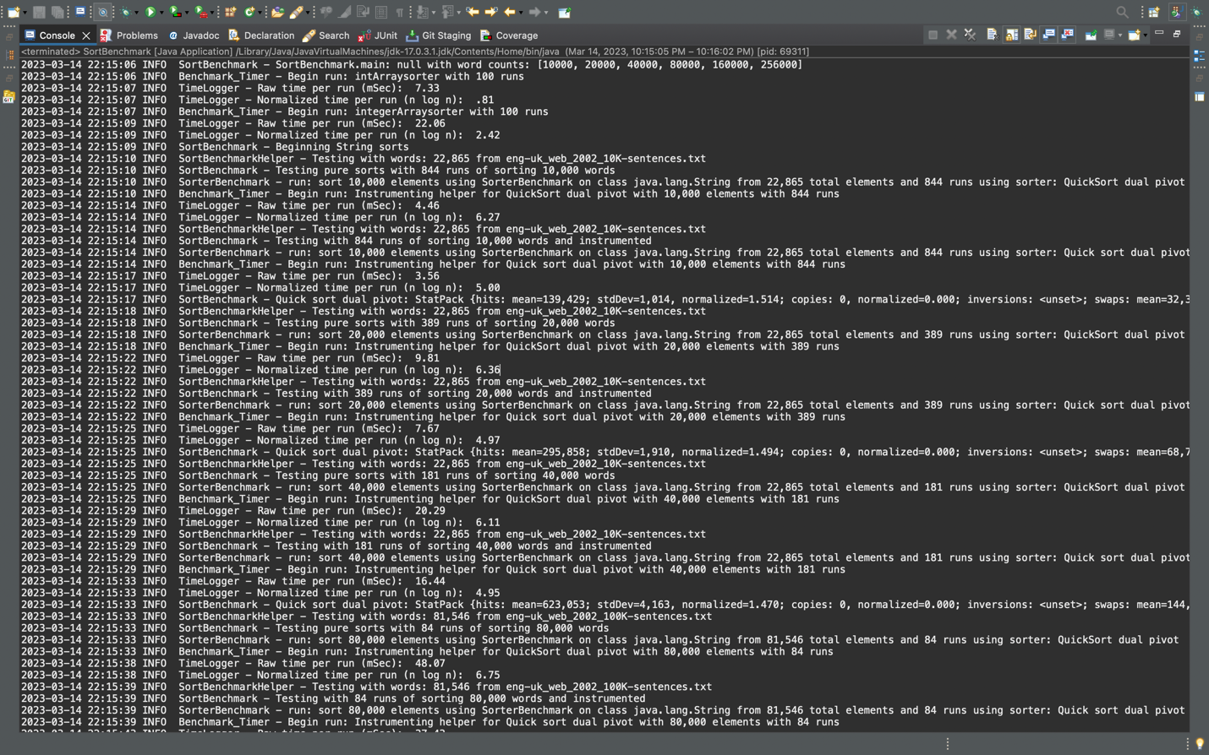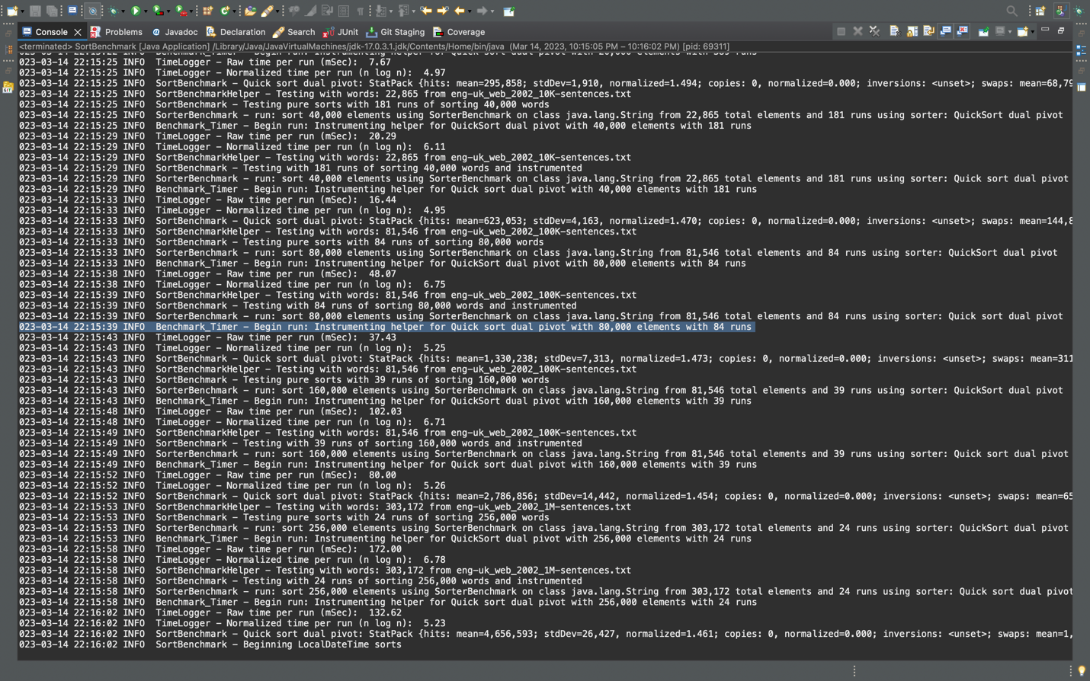

**Test case:**

